**Lab Report**

Title: Spactime Cubes, TINs and DEMs

Notice: Dr. Bryan Runck

Author: Ethan Bott

Date: 11/2/22

**Project Repository:** <https://github.com/swimbott/GIS5571/tree/main/Lab2>

**Time Spent:** *25*

**Abstract**

An ETL data pipeline will be built that will download LAS files from the MN DNR where they will be converted in DEM and TINs and then exported. These two will be compared to each other, one as the 2D map and the other as a 3D scene. Finally, the 30 year precipitation data will be downloaded and converted into spacetime cubes where it will all be exported as an animation to show the precipitation over time for the country.

**Problem Statement**

Create an ETL pipeline of lidar data from the MN Geospatial Commons and then convert it to both a DEM and a TIN where it can be exported as a PDF to show the result. Compare a 2D map and a 3D scene of the lidar data and compare the features that are provided by ArcGIS for working on the lidar files. Create an ETL pipeline of 30 years of precipitation data and convert it to a spacetime cube where it can be exported as an animation showing the timeseries of precipitation data.

*Table 1. Required data for this project*

|  |  |  |  |  |  |  |
| --- | --- | --- | --- | --- | --- | --- |
| **#** | **Requirement** | **Defined As** | **(Spatial) Data** | **Attribute Data** | **Dataset** | **Preparation** |
| 1 | Lidar data | To create DEM and TINs form them | Las file | Elevation | MN DNR | ETL |
| 2 | 30 year precipitation | To create animation of timeseries | Bill files | Precipitation | PRISM | ETL |

**Input Data**

These data are lidar data that contains elevation data for a small area in Minnesota. This will be used to construct DEM’s and TIN’s that will then be converted to 3D representations. The other dataset is precipitation data over 30 years for the United States that will be animated to show the change over time.

*Table 2. Data used for this project*

|  |  |  |  |
| --- | --- | --- | --- |
| **#** | **Title** | **Purpose in Analysis** | **Link to Source** |
| 1 | Lidar data | To create DEM and TIN’s from them | [Mn GeoSpatial Commons](https://resources.gisdata.mn.gov/pub/data/elevation/lidar/examples/lidar_sample/las/) |
| 2 | 30 year precipitation | To create animation of timeseries | [PRISM](https://prism.oregonstate.edu/normals/) |

**Methods**

*Figure 1. Data flow diagram.*

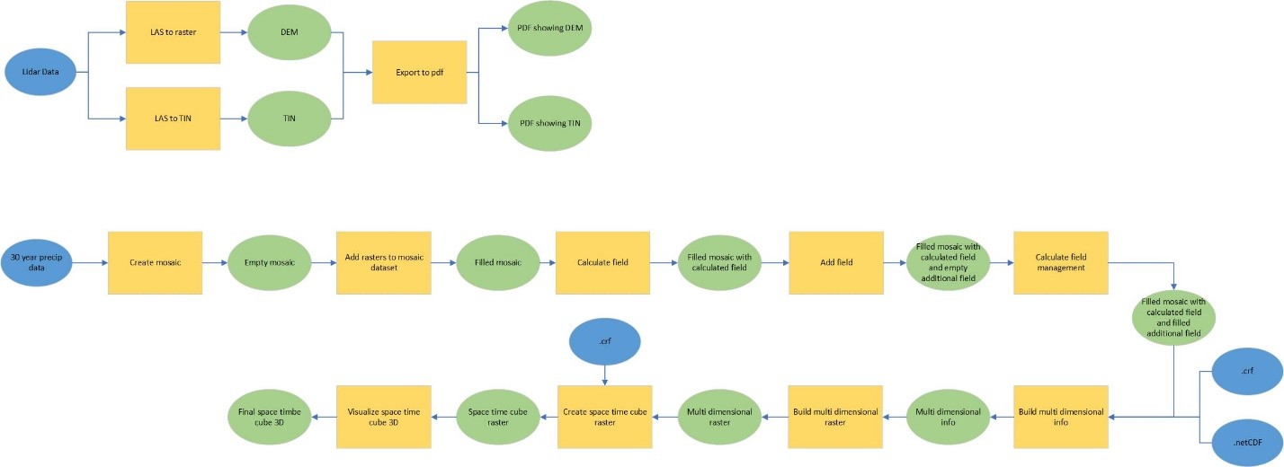

Part 1.1

The first step was to download the data using an ETL data pipeline bringing in the data from the MN geospatial commons site. Once all the las files were brought in and unzipped into an ArcNotebook environment, the las to raster tool was used to create a DEM out of the lidar data (Figure 2). Similarly, a las to TIN tool was used to create a TIN from the lidar data (Figure 3). This was then exported as a high-resolution pdf with appropriate cartographic elements.

Part 1.2

This part involved comparing one of the lidar files with it’s 3D counterpart. The 3D scene allows one to manipulate and show varying parts of the lidar data. There are four options to manipulate ones data. The first option involved symbolizing one’s layer using points (Figure 4). One could change the color scheme, draw data by elevation, scan angle, etc. The symbol scale could also be changed. The second option was symbolizing one’s layer using contours (Figure 5). One could change the contour interval, reference height and the index factor. The third option was to symbolize one’s layer using edges where the only option to alter the data was by drawing with a simple or edge type (Figure 6). The color could be changed as well. And the final option was to symbolize one’s layer using a surface where it could be drawn using elevation, slope or aspect (Figure 7). The method of drawing could be done by natural breaks, quantile, equal interval, etc. And then finally the classes and color scheme could be changed as well. This aspect is very similar to symbolizing a normal feature class.

Part 1.3

The first step was bringing in the 30-year Normals .bill files through and ETL data pipeline. Once they brought in and unzipped in an ArcNotebook environment, a mosaic dataset was created. The add rasters to mosaic tool was run where all the downloaded rasters were put into the mosaic dataset. Then the precipitation field had to be set to a variable and a new field had to be added. This new field was populated with the timestamp. Then the build multidimensional info tool was run to provide the basis for the make multi dimensional raster (Figure 8). From this multi dimensional raster, a space time cube was created. And finally, it was visualized as an animation in the GUI environment of ArcGIS Pro as a gif file (Animation 1).

**Results**

One can see the following results of the analysis for when lidar data was converted to a DEM and TIN and for when the lidar data was compared against each other in 2D and 3D space.

*Figure 2. DEM created from Lidar data.*

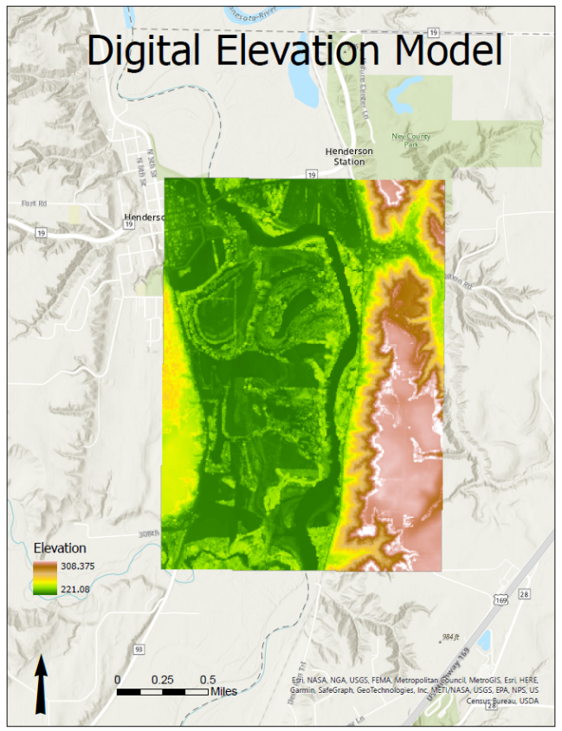

*Figure 3. TIN created from Lidar data.*

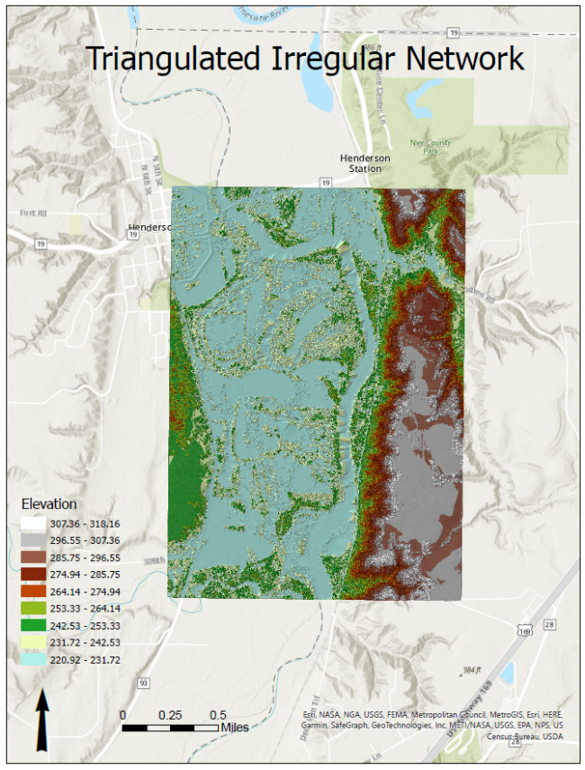

*Figure 4. 2D and 3D comparison using a point symbolization.*

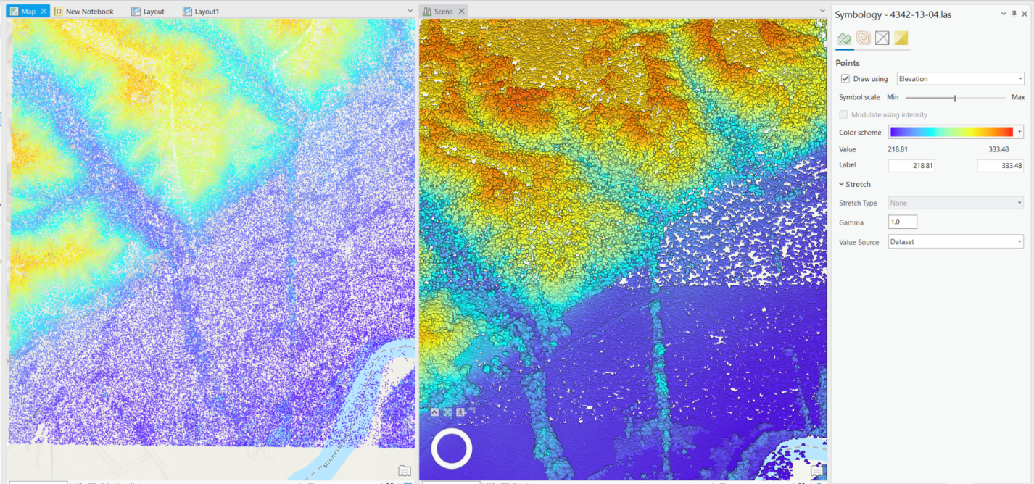

*Figure 5. 2D and 3D comparison using a contour symbolization.*

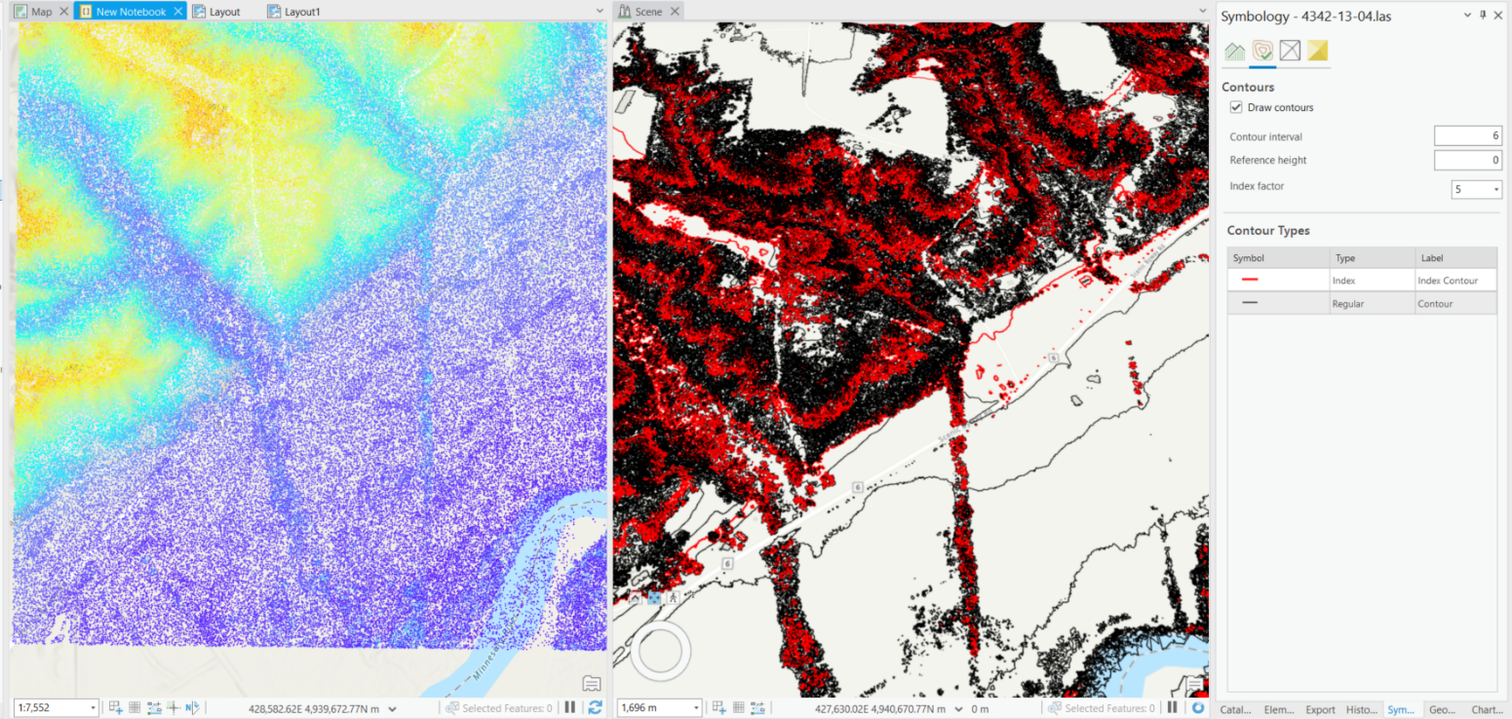

*Figure 6. 2D and 3D comparison using an edge symbolization.*

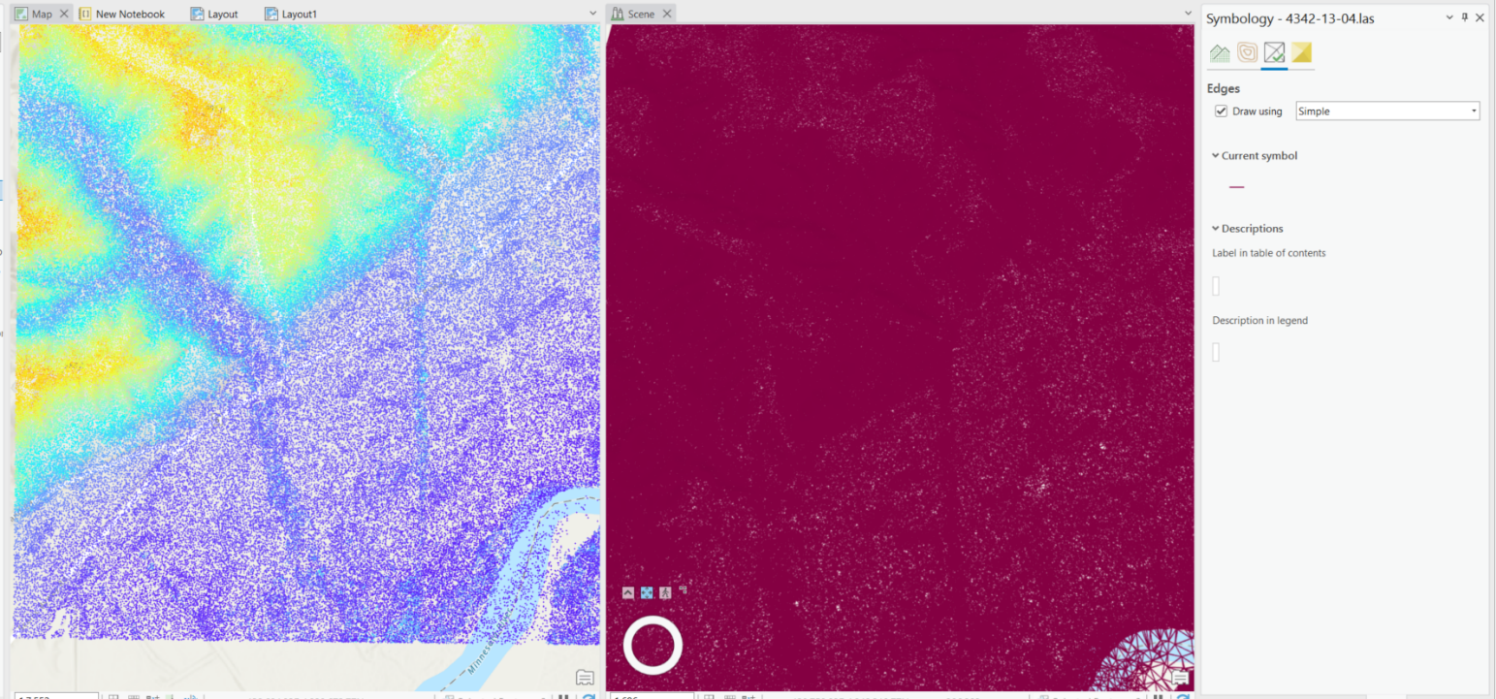

*Figure 7. 2D and 3D comparison using a surface symbolization.*

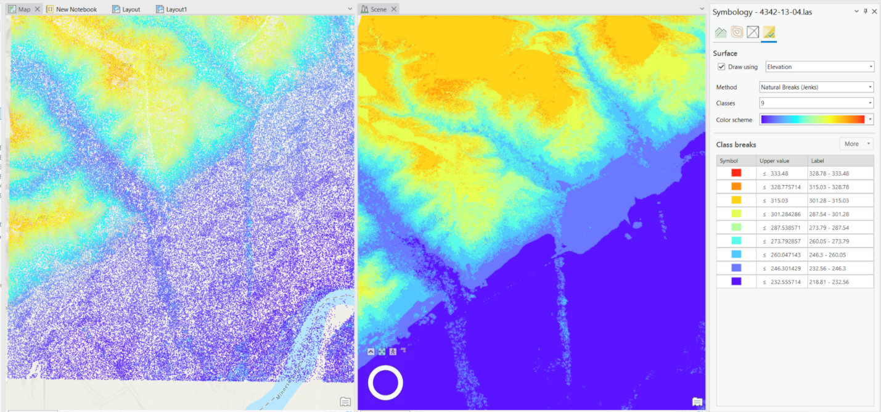

*Figure 8. Multidimensional raster layer showing precipitation across the United States.*

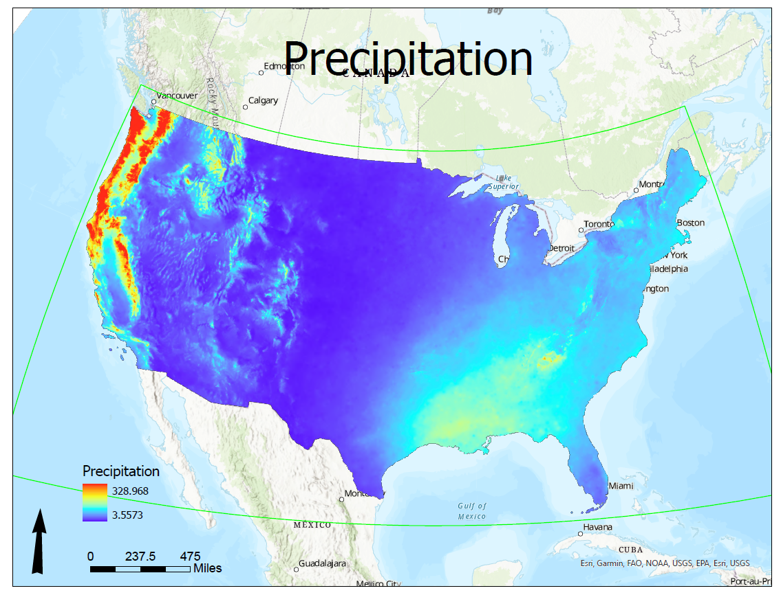

*Animation 1. Animation of precipitation changes for the year of 2018.*

**

**Results Verification**

There were no results to be verified in all of part 1. It was just creating nice graphics and seeing how things compared to each other. For part 1.1, I made sure to use the same spatial extent when creating the DEM and TIN from the same lidar file.

For part 1.2, I made sure to use the same special extent as I compared and contrasted the different ways to show 3D space against the same space for the 2D representation.

For part 1.3, I knew that I had done things correctly when I made the gif of the precipitation and I saw it change over the year. I knew in the PNW, that there would be a lot of precipitation in the fall and winter and less in the summer. And it indeed looked like that.

**Discussion and Conclusion**

It was cool to create a DEM and a TIN from lidar data. I had never done that or had known one could do that. I just always started with a DEM or with point data to create a TIN. I was surprised with how easy it was to create them simply from the lidar data using a single ArcPro tool.

It was also cool to compare the lidar data in a 2D and a 3D format. I have never visualized any data in a 3D form so that was cool to see and know I can manipulate how it looks in the 3D world.

And finally, it was very cool to see the final result of precipitation data over a year for the United States as a gif and to have that visualization. I have never worked with spacetime cubes or multidimensional rasters, so it was great to work with them.

Through all this the workflow of getting the data into a workable format has been the hardest for me. Once I have things in the notebook, it flows relatively easily as I am able to visualize and understand each step, why it needs to be done and the resulting output.

**References**

How to use arcpy.mp

<https://pro.arcgis.com/en/pro-app/latest/arcpy/mapping/introduction-to-arcpy-mp.htm>

Create space time cube from multidimensional raster

<https://pro.arcgis.com/en/pro-app/latest/tool-reference/space-time-pattern-mining/createcubefrommdrasterlayer.htm>

Lidar data source

<https://resources.gisdata.mn.gov/pub/data/elevation/lidar/>

30-Year Normals data source

<https://prism.oregonstate.edu/normals/>

Exploring raster data with space time pattern mining

<https://www.esri.com/arcgis-blog/products/arcgis-pro/analytics/explore-your-raster-data-with-space-time-pattern-mining/>

**Self-score**

|  |  |  |  |
| --- | --- | --- | --- |
| **Category** | **Description** | **Points Possible** | **Score** |
| **Structural Elements** | All elements of a lab report are included **(2 points each)**:  Title, Notice: Dr. Bryan Runck, Author, Project Repository, Date, Abstract, Problem Statement, Input Data w/ tables, Methods w/ Data, Flow Diagrams, Results, Results Verification, Discussion and Conclusion, References in common format, Self-score | 28 | **28** |
| **Clarity of Content** | Each element above is executed at a professional level so that someone can understand the goal, data, methods, results, and their validity and implications in a 5 minute reading at a cursory-level, and in a 30 minute meeting at a deep level **(12 points)**. There is a clear connection from data to results to discussion and conclusion **(12 points)**. | 24 | **24** |
| **Reproducibility** | Results are completely reproducible by someone with basic GIS training. There is no ambiguity in data flow or rationale for data operations. Every step is documented and justified. | 28 | **28** |
| **Verification** | Results are correct in that they have been verified in comparison to some standard. The standard is clearly stated **(10 points)**, the method of comparison is clearly stated **(5 points)**, and the result of verification is clearly stated **(5 points)**. | 20 | **20** |
|  |  | 100 | **100** |